Purpose: To serve as a guideline for the use of PAXLOVID™ (nirmatrelvir tablets; ritonavir tablets) in the treatment management of residents with mild-to-moderate COVID-19, and who are at high risk for progression to severe COVID-19, including hospitalization or death, and who meet the criteria set-forth by either the Emergency Use Authorization (EUA), or the approved New Drug Application (NDA) by the Food and Drug Administration (FDA).
PAXLOVID™ EUA & NDA Indications for Use
EUA: PAXLOVID™ (nirmatrelvir tablets; ritonavir tablets) has not been approved, but has been authorized for emergency use by FDA under an EUA, for the treatment of mild-to-moderate COVID-19 in adults and children 12 years of age and older weighing at least 88 pounds (40kg) who are at high risk for progression to severe COVID-19, including hospitalization or death.
NDA: PAXLOVID™ (nirmatrelvir tablets; ritonavir tablets) under NDA is FDA-approved for the treatment of mild-to-moderate COVID-19 in adults who are at high risk for progression to severe COVID-19, including hospitalization or death. The NDA-labeled PAXLOVID™ has been added under the same use guidelines as the EUA-labeled PAXLOVID™ during transition from USG-procured supply to NDA-commercial supply.
Further information may be found at:
- https://www.fda.gov/media/155052/download
- http://www.covid19oralrx.com/
- https://labeling.pfizer.com/ShowLabeling.aspx?id=19599
PAXLOVID™ Treatment Guidance
Inclusion Criteria | - The resident is 12 years of age or older.  - The resident’s weight is at least 88lbs (40kg).  - The resident has positive results of a SARS-CoV-2 test (rapid or PCR) OR  The resident has been diagnosed with COVID-19 based on symptomatic presentation consistent with COVID-19 disease secondary to high-risk transmission and contact (facility outbreak).  - Symptom onset or positive COVID-19 test within the last 5 days.  - The resident is able to swallow tablets whole.
Categorization of Illness Criteria | Disease Category Illness Presentation Category Progression Clarifications & Special Considerations  Asymptomatic/ Presymptomatic (Continue to monitor for symptoms and review for treatment with Paxlovid as appropriate) Resident will have a positive COVID-19 test, but no known symptoms/complaints consistent with COVID-19. *Carefully review for mild or atypical symptoms that may have been present, but not recognized as being related to COVID-19 illness prior to diagnosis. Likelihood of resident remaining asymptomatic, or truly being asymptomatic, is very low, especially in residents with cognitive dysfunction, or ability to communicate (thoughts, feelings, symptoms, etc.) impaired (i.e., dementia, aphasia, stroke, psychiatric disorders, etc.).  Mild Illness (Review for treatment with Paxlovid) Resident will have one or more symptoms consistent with COVID-19 (fever, cough, dry, scratchy, or sore throat, hoarse voice, poor oral intake, falls, dizziness, delirium, confusion, agitation, weakness, malaise, lethargy, headache, loose stools, loss of smell and/or taste, nausea, vomiting, muscle/body aches, etc.). Resident will NOT have any of the following: Shortness of breath, dyspnea on exertion, evidence of lower respiratory disease on either clinical assessment, or CXR.  Moderate Illness (Review for treatment with Paxlovid) Resident will present with any number of mild illness symptoms listed above, AND will present with evidence of lower respiratory disease (i.e., abnormal lung sounds, shortness of breath, dyspnea, tachypnea, etc.) upon clinical assessment and/or CXR. Resident will NOT have: O2 saturation ≤94% on room air, have a new need for oxygen, or if resident is on routine/chronic O2, they will not have a need for an increase in their normal/baseline oxygen needs. *Closely monitor these residents as they can rapidly progress into severe/critical illness.  Severe Illness (Do Not use Paxlovid) Resident will present with moderate illness AND will have an O2 saturation ≤94% on room air, or will have a new need for oxygen, or if resident is on routine/chronic O2, they will have an increased need in their normal/baseline oxygen needs, respiratory rate of greater than 30 breaths/min, or lung infiltrates of more than 50% seen on chest imaging. These residents may or may not need hospitalization. *Ensure you have carefully reviewed MOLST/Goals of Care with resident and/or healthcare decision maker- update as needed.  Critical Illness (Do Not use Paxlovid) Resident will present with severe illness AND present with Acute Respiratory Failure/Distress Syndrome, Septic Shock, Cardiac Shock, organ failure, an exaggerated inflammatory response, or thrombotic disease. These residents are hospitalized, unless MOLST/Goals of Care are for comfort measures and no hospitalizations.
High-Risk Conditions | - Age 50 and older  - Obesity or being overweight (BMI ≥25kg/m2)  - Chronic kidney disease  - Cancer (hematologic malignancies)  - Cerebrovascular disease  - Diabetes  - Immunosuppressive disease or immunosuppressive treatment  - Cardiovascular disease such as, hypertension, heart failure, coronary artery disease, and cardiomyopathies  - Chronic lung disease such as chronic obstructive lung disease, pulmonary hypertension, moderate-to-severe asthma, interstitial lung disease, and cystic fibrosis  - Chronic liver disease (Cirrhosis, non-alcoholic fatty liver disease, alcoholic liver disease, autoimmune hepatitis)  - Dementia  - Neurodevelopmental disorders such as cerebral palsy  - HIV  This list does not include all conditions that could increase risk of progression to severe COVID-19 including hospitalization or death. Please review all resident conditions with provider in order to make appropriate decision for treatment. Full list of underlying conditions that increase the risk of progression to severe disease can be found at:  - Underlying Medical Conditions Associated with Higher Risk for Severe COVID-19: Information for Healthcare Professionals | CDC  - Clinical Spectrum | COVID-19 Treatment Guidelines (nih.gov)
Exclusion Criteria | - The resident is younger than 12 years old  - The resident weighs less than 40kg (88.2lbs)  - Tested positive for or, began with symptoms consistent with COVID-19 more than 5 days ago  - The resident has a new requirement for oxygen therapy due to COVID-19, OR  the resident requires an increase in baseline oxygen flow rate due to COVID-19 in those on chronic oxygen therapy due to underlying non-COVID-19 related condition  - History of clinically significant hypersensitivity reactions to the active ingredients (nirmatrelvir or ritonavir) or any other components  - Co-administration with drugs highly dependent on CYP3A for clearance and for which elevated concentrations are associated with serious and/or life-threatening reactions  - Co-administration with potent CYP3A inducers where significantly reduced nirmatrelvir or ritonavir plasma concentrations may be associated with the potential for loss of virologic response and possible resistance  - Inability to swallow tablets whole, PAXLOVID™ cannot be crushed or chewed  - Has severe renal impairment (eGFR<30 mL/min)  - Has severe liver impairment (Child-Pugh Class C)  - The resident is hospitalized due to severe or critical COVID-19
Contraindicated Concomitant Medications | Ritonavir-boosted nirmatrelvir (PAXLOVID™) has significant drug-drug interactions, primarily due to the ritonavir component of the combination. Before prescribing ritonavir-boosted nirmatrelvir, clinicians should carefully review the patient’s concomitant medications, including over-the-counter medications, herbal supplements, and recreational drugs, to evaluate potential drug-drug interactions.  - For some of these medications, management strategies are NOT possible or feasible and require an alternative COVID-19 therapy. In some instances, temporarily withholding the concomitant medication or using an alternative to the concomitant medication is clinically appropriate. You may refer to the University of Liverpool COVID-19 Drug Interactions page, paxlovid.com Healthcare Provider DDI Pocket Resource Guide, or your participating pharmacist/pharmacy consultant for further assistance and direction.    https://paxlovid.pfizerpro.com/dosing  https://www.covid19-druginteractions.org/checker
Limitations to Authorized Use | - PAXLOVID is not authorized for initiation of treatment in patients requiring hospitalization due to severe or critical COVID-19.  - PAXLOVID™ is not authorized for use as pre-exposure or post-exposure prophylaxis for prevention of COVID-19.  - PAXLOVID™ is not authorized for use for longer than 5 consecutive days.
PAXLOVID™ Administration Procedure
Consent | - Consent form for PAXLOVID™ to be completed.  - If the resident has medical decision-making capacity, then they may sign the consent for treatment themselves.  If the resident lacks capacity for medical decision making, then the appointed healthcare decision maker will need to complete the consent. This can be completed verbally over the phone with two witnesses to the conversation, or e-mailed to the HCP/medical decision maker, signed and returned to the facility.
Resident Education Materials | - Provide resident or resident’s HCP/medical decision maker with a copy of the most recent version of the patient fact sheet: https://www.fda.gov/media/155051/download  - Educate importance of starting therapy as soon as possible.  - Review risk vs. benefit of therapy.
Review Prior to Prescribing | - Calculate eGFR to accurately prescribe PAXLOVID™.  - Residents’ ability to swallow tablets whole.  - All medications and allergies to ensure no contraindications to use.

Common Side Effects | - Altered sense of taste  - Diarrhea  - High blood pressure  - Muscle aches  - Abdominal pain  - Nausea  - Feeling generally unwell
Ordering PAXLOVID™ | - PAXLOVID™ is available in two Dose Packs: Standard Dose and Reduced Dose (Renal Dose).  - Standard Dosing: 2 nirmatrelvir 150mg tablets (300mg) and 1 ritonavir 100mg tablet, taken together, twice daily, with or without food for 5 days.  - No known/suspected renal impairment  (eGFR ≥90 mL/min) OR patient has mild renal  impairment eGFR ≥60 mL/min to <90 mL/min).  - Moderate Renal Impairment Dosing/Reduced Dose: 1 nirmatrelvir 150mg tablet (150mg) and 1 ritonavir 100mg tablet, taken together, twice daily, with or without food for 5 days.  - Resident has moderate renal impairment  (eGFR ≥ 30mL/min to < 60mL/min).  ∗No dosage adjustment is recommended for those with mild  (Child-Pugh Class A) or moderate (Child-Pugh Class B) hepatic impairment.  ∗No dosage adjustment is recommended for those with mild  renal impairment (eGFR ≥60 to <90 mL/min).
EUA & NDC Standard Dosing Packaging & Schedule | 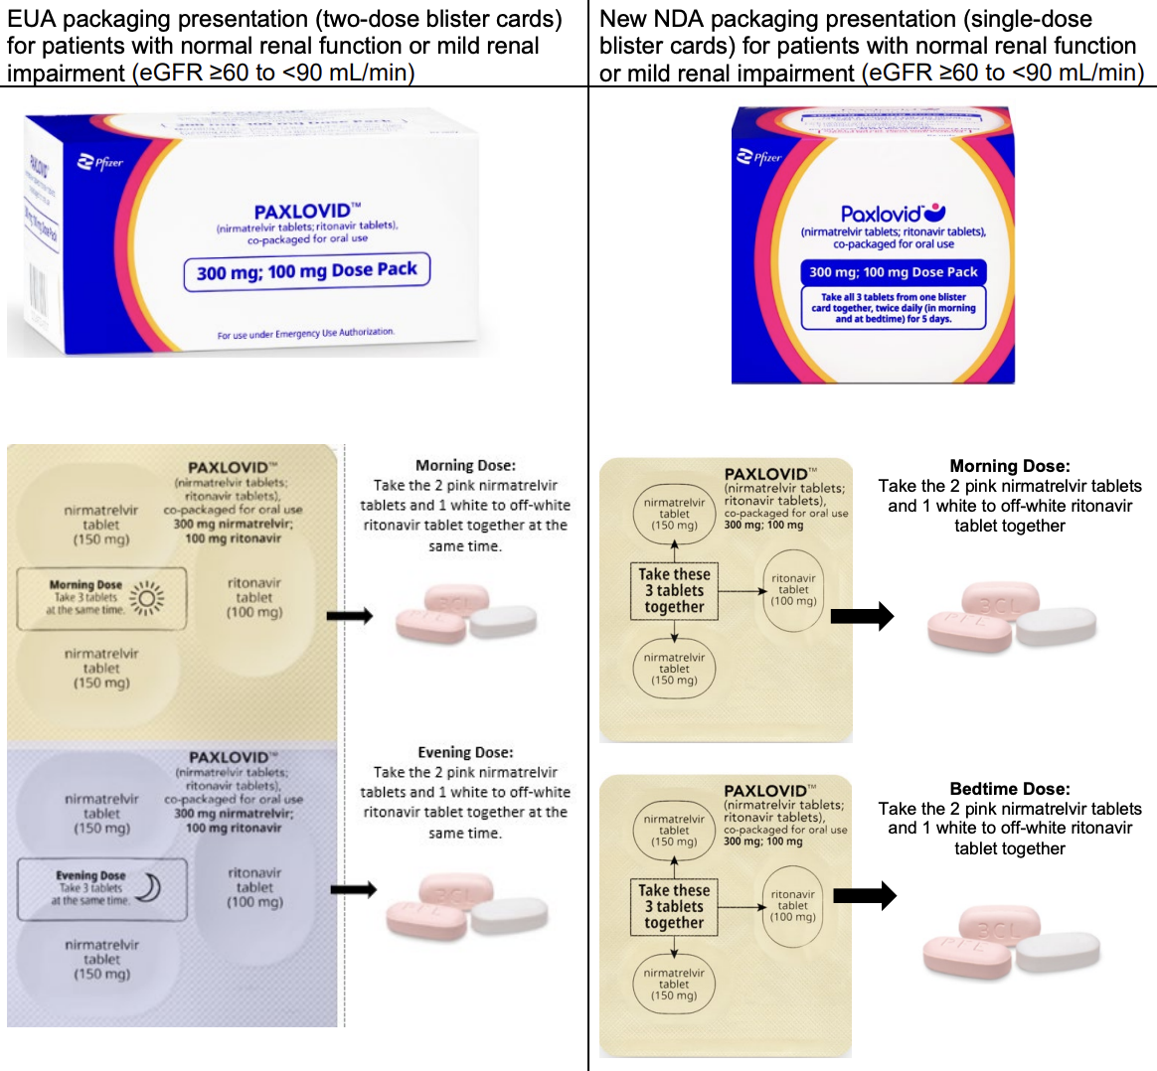  - Morning Dose: ALL 3 tablets (2 pink nirmatrelvir tabs & 1 white ritonavir tab) are to be administered at the same time together each morning for 5 days.  - Evening Dose: ALL 3 tablets (2 pink nirmatrelvir tabs & 1 white ritonavir tab) are to be administered at the same time (together) each evening for 5 days.  - Both the Morning Dose and the Evening Dose are to be administered every day for 5 consecutive days.
EUA & NDC Reduced Dosing/Renal Dose Schedule | 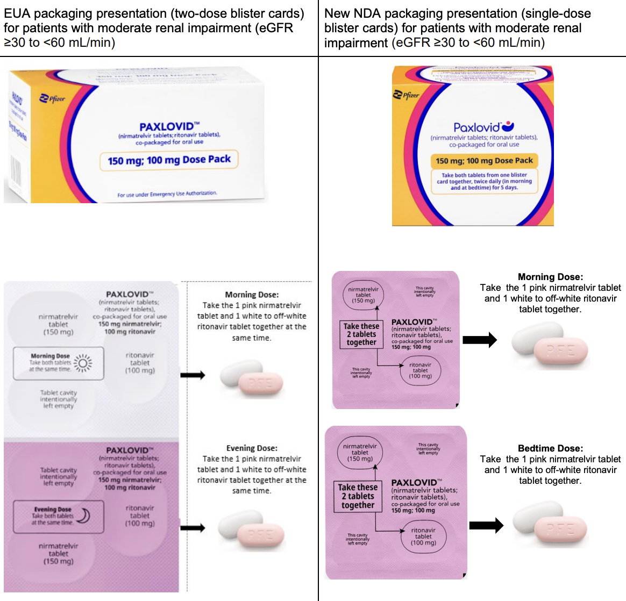  - Morning Dose: BOTH tablets (1 pink nirmatrelvir tab & 1 white ritonavir tab) are to be administered at the same time (together) each morning for 5 days.  - Evening Dose: BOTH tablets (1 pink nirmatrelvir & 1 white ritonavir tab) are to be administered at the same time (together) each evening for 5 days.  - Both the Morning Dose and the Evening Dose are to be administered every day for 5 consecutive days.
References:
- https://www.paxlovidhcp.com
- https://paltc.org/sites/default/files/Vax%20and%20Pax%20toolkit_11_14_FINAL.pdf
- https://www.covid19-druginteractions.org
- https://www.fda.gov/media/155071/download
 | POLICY TITLE: PAXLOVID™ (nirmatrelvir tablets; ritonavir tablets)
 | Authorization: | Date Approved: | Current Version Date:  11/22/2023

Version | Date | Comments/Changes
1.0 | 11/10/2023 | Initial Policy Released

