Purpose: To minimize the morbidity and mortality through vaccination of facility employees and residents aged 65 and older whom are at higher risk for developing pneumococcal disease, as well as those under the age of 65 with certain high risk health conditions as recommended by the Centers for Disease Control (CDC) and Prevention’s Advisory Committee on Immunization Practices (ACIP).
Pneumococcal Vaccination for Employees and Residents
Policy | - Under this non-patient specific standing order, Registered Nurses (RN), Advanced Practice Providers (APP), or Physicians, who are employees, and/or contractors of (insert facility name) may administer the pneumococcal vaccine to facility employees and residents that have consented to receive and meet the criteria to receive the vaccine in accordance with the CDC’s Vaccination Program and recommendations issued by ACIP.  - The facility will routinely review for need for, offer, and provide the pneumococcal vaccine to employees and residents of (insert facility name) as required and recommended by the New York State Department of Health (NYSDOH) and CDC.
Non-Patient Specific Standing Order- NYSED Nursing Guideline Overview | - A non-patient specific order authorizes named RN’s or RN’s who are not individually named but employed or under contract with a legally authorized entity, to administer specified immunization agents or anaphylaxis treatment agents for a specified period of time to an entire group of persons such as school children, employees, patients of a nursing home, etc.  - The non-patient specific standing order and protocol must be authorized by a physician or certified nurse practitioner.  - RN’s must maintain or ensure that a copy of the standing order(s) and protocol(s) authorizing them to administer immunizations is maintained.  - An LPN can assist in administering immunizations (give the injection, assist in recordkeeping, and when appropriate, administer anaphylactic agents) as long as the RN assesses the recipient, and is responsible for the on-site direction of the LPN in administering the immunizations. It is expected that, in this setting a ratio is maintained of no more than three LPN’s to one RN.  - An RN may assign the actual injection of the vaccine to an LPN.
Communication and Education | - The facility will communicate, educate, support, and strongly encourage, for all qualified staff and residents to be vaccinated, and will provide individual opportunities for education, questions and concerns to be discussed and addressed in order to reduce vaccine hesitancy and possible negative outcomes related to pneumococcal disease.  - The facility will review, offer, and provide the pneumococcal vaccine to all qualified facility employees and residents upon new employment/new admission to the facility, change in qualification status, and as determined/recommended by the facility’s medical director, or by residents attending provider.  - Prior to vaccination and or declination of vaccination, information and education will be provided about the pneumococcal vaccine and the importance of receiving it, as well as possible consequences and outcomes of refusing vaccination.
Vaccination Assessment and Review
Assess Need for Pneumococcal Vaccination | - Adults aged 65 years and older are recommended to receive routine administration of pneumococcal conjugate vaccine (PCV15 or PCV20) who have never received any pneumococcal conjugate vaccine or whose vaccination history is unknown.  - Review medical records (e.g., NYSIIS, hospital electronic health record [EHR], Primary Care Provider [PCP] EHR, etc.) in order to facilitate immunization review and documentation.  - If unable to locate written documentation of vaccination administration, it is acceptable to rely on individuals verbal immunization history to determine whether and which pneumococcal vaccine is indicated.  - If employee/resident/resident decision maker is unable to recall receiving the pneumococcal vaccine, they should be vaccinated per CDC recommendations.  - Adult’s aged 19-64 years old with any of the following conditions:  - Non-immunocompromising chronic health conditions¶: Alcohol abuse disorder, chronic heart disease, chronic liver disease, chronic lung disease, cigarette smoking, diabetes mellitus, cochlear implant, cerebrospinal fluid (CSF) leak.  - Immunocompromising conditions¶: Chronic renal failure, congenital or acquired asplenia, congenital or acquired immunodeficiencies, generalized malignancy, HIV infection, Hodgkin disease, iatrogenic immunosuppression, leukemia, lymphoma, multiple myeloma, nephrotic syndrome, sickle cell disease and other hemoglobinopathies, solid organ transplant.  ¶ For any employee in this category the decision for vaccination should include the employee’s PCP and or other specialty care provider involved in the care of these conditions. Therefore, due to the specific nature related to decisions in treatment and care, including the decision to administer the pneumococcal vaccination to these individual employees, they will be referred to their PCP and or specialty care provider for pneumococcal vaccination decisions/recommendations.  - PneumoRecs VaxAdvisor mobile app helps vaccination providers quickly and easily determine which pneumococcal vaccines an individual needs and when. Find app here: https://www.cdc.gov/vaccines/vpd/pneumo/hcp/pneumoapp.html
Screen for Contraindications and Precautions | - Contraindications for vaccination:  - Do not administer a pneumococcal conjugate vaccine to anyone who has ever had a severe systemic or anaphylactic reaction after a previous dose of PCV7, PCV13, PCV15, or PCV20, or to any vaccine containing diphtheria toxoid.  - Do not administer a pneumococcal polysaccharide vaccine to anyone who has ever had a severe systemic or anaphylactic reaction after a previous dose of PPSV23, or are allergic to component of this vaccine.  - If there is any concern or question to previous reaction do not vaccinate and refer to healthcare provider for further guidance.  - Precautions for use of vaccine:  - Moderate or severe acute illness with or without fever.
Shared Clinical Decision-Making | - Based on shared clinical decision-making, adults 65 years or older have the option to get PCV20 if they have received:  - PCV13 (but not PCV15 or PCV20) at any age;  And  - PPSV23 at or after the age of 65 years old  - Utilize the shared clinical decision-making job aid to assist in discussions about this vaccine recommendation and may be completed by a physician, physician assistant, nurse practitioner, registered nurse, or pharmacist.  - Shared Clinical Decision-Making Job Aid may be found at: https://www.cdc.gov/vaccines/hcp/admin/downloads/job-aid-SCDM-PCV20-508.pdf
Vaccine Information Statements | - Provide all individuals receiving the pneumococcal vaccine with the most current pneumococcal Vaccine Information Statement (VIS) in their preferred language.  - Residents/healthcare decision makers may have previously received VIS at time consent was signed, if not previously received, then provide.  - Pneumococcal VIS may be found at: https://www.cdc.gov/vaccines/hcp/vis/vis-statements/pcv.html
Consent to Vaccinate | - Collect and review the Vaccine Consent or the Confirmed Shared Clinical Decision-Making Occurrence and Consent.  - Ensure all information is reviewed and completed appropriately.  - Confirm the appropriate Consent has been Signed.
Special Considerations | - When administering vaccines ensure you are prepared to respond to, and manage medical emergencies related to vaccination administration. Be familiar with, and have, written emergency medical protocols available in addition to, emergency medications and equipment.
Vaccination Schedule, Dosing, Preparation and Administration
Recommended Pneumococcal Vaccination Administration Schedules | - PneumoRecs VaxAdvisor mobile app helps vaccination providers quickly and easily determine which pneumococcal vaccines an individual needs and when. Find app here: https://www.cdc.gov/vaccines/vpd/pneumo/hcp/pneumoapp.html  Recommendations for Adults Age 65 Years or Older  Prior Vaccines Received Option A Schedule Option B Schedule  None, unknown, or PCV7 only Give PCV20 Give PCV15 followed by PPSV23 in at least 1 year**  PPSV23 only (at any age) Give PCV20 at least 1 year after PPSV23 Give PCV15 at least 1 year after PPSV23  PCV13 only (at any age) Give PCV20 at least 1 year after PCV13 Give PPSV23 at least 1 year** after PCV13  PCV13 (at any age) & PPSV23 before age 65 years Give PCV20 at least 5 years after last pneumococcal vaccine dose Give 2nd dose PPSV23 at least 5 years after previous PPSV23†  Complete series of PCV13 at any age & PPSV23 at age 65 years or older May administer PCV20 at least 5 years after most recent pneumococcal vaccination. Utilize the shared clinical decision-making job aid to assist in discussions about this vaccine recommendation.  **Consider minimum interval (8 weeks) for adults with an immunocompromising condition, cochlear implant, or CSF leak.  † For adults with an immunocompromising condition, cochlear implant, or CSF leak, the minimum interval for PPSV23 is at least 8 weeks since last PCV13 dose and at least 5 years since last PPSV23 dose; for others, the minimum interval for PPSV23 is at least 1 year since last PCV13 dose and at least 5 years since last PPSV23 dose.  Recommendations for Adults Age 19-64 Years w/Specified Immunocompromising Conditions  Prior Vaccines Received Option A Schedule Option B Schedule  None, unknown, or PCV7 only Give PCV20 Give PCV15 followed by PPSV23 in at least 8 weeks  PPSV23 only Give PCV20 at least 1 year after PPSV23 Give PCV15 at least 1 year after PPSV23  PCV13 only Give PCV20 at least 1 year after PCV13 Give 1st dose PPSV23 at least 8 weeks after PCV13, followed by a second dose PPSV23 in at least 5 years  PCV13 & 1 dose of PPSV23 Give PCV20 at least 5 years after last pneumococcal vaccine dose Give 2nd dose PPSV23 at least 5 years after 1st dose of PPSV23 and at least 8 weeks after PCV13  PCV13 and 2 doses of PPSV23 May administer PCV20 at least 5 years after last pneumococcal vaccine dose (if PCV20 not given, it is recommended that a review for further pneumococcal vaccination recommendations is done once the individual turns 65 years old).  Recommendations for Adults Age 19-64 Years with a Cochlear Implant or Cerebrospinal Leak  Prior Vaccines Received Option A Schedule Option B Schedule  None, unknown, or PCV7 only Give PCV20 Give PCV15 followed by PPSV23 in at least 8 weeks  PPSV23 only Give PCV20 at least 1 year after PPSV23 Give PCV15 at least 1 year after PPSV23  PCV13 only Give PCV20 at least 1 year after PCV13 Give PPSV23 at least 8 weeks after PCV13  PCV13 & 1 dose of PPSV23 May give PCV20 at least 5 years after last pneumococcal vaccine dose (if PCV20 not given, it is recommended that a review for further pneumococcal vaccination recommendations is done once the individual turns 65 years old).  Recommendations for Adults Age 19-64 with a Non-Immunocompromising Chronic Health Condition  Prior Vaccines Received Option A Schedule Option B Schedule  None, unknown, or PCV7 only Give PCV20 Give PCV15 followed by PPSV23 in at least 1 year  PPSV23 only Give PCV20 at least 1 year after PPSV23 Give PCV15 at least 1 year after PPSV23  PCV13 only Give PCV20 at least 1 year after PCV13 Give PPSV23 at least 8 weeks after PCV13  PCV13 & 1 dose of PPSV23 No additional pneumococcal vaccines are recommended at this time (review further recommendations for pneumococcal vaccination once individual turns 65 years old).
Pneumococcal Vaccination Orders | Administer the dose of PCV15, PCV20, or PPSV23 (per order table below), according to recommended dose needed based on the recipient’s history of pneumococcal vaccination and choice of either the Option A Schedule or the Option B Schedule (refer to above Recommended Pneumococcal Vaccination Administration Schedules tables).  Vaccination Type Trade Name Packaging Availability, Storage & Preparation Administration Order  Pneumococcal Conjugate PCV15, Vaxneuvance™ (Merck) 0.5mL pre-filled single dose syringe- Store refrigerated at 2°C to 8°C (36°F to 46°F). Do Not Freeze. Protect from light. - Hold the prefilled syringe horizontally and shake vigorously immediately prior to use to obtain an opalescent suspension. - Do not use the vaccine if it cannot be resuspended. - Parenteral drug products should be inspected visually for particulate matter and discoloration prior to administration, whenever solution and container permit. - Do not use if particulate matter or discoloration observed. Give 0.5mL by intramuscular route x1 Dx. Z23: Encounter for immunization  Pneumococcal Conjugate PCV20, Prevnar 20® (Pfizer) 0.5mL pre-filled single dose syringe- Upon receipt, store refrigerated at 2°C to 8°C (36°F to 46°F). Syringes should be stored in refrigerator horizontally to minimize the resuspension time. Do Not Freeze. Discard if the vaccine has been frozen. Administer as soon as possible after being removed from refrigeration. - See below instructions for preparation. Give 0.5mL by intramuscular route x1 Dx. Z23: Encounter for immunization  Pneumococcal Polysaccharide PPSV23, Pneumovax® 23 (Merck) 0.5mL single dose vial (color coded with a purple cap and stripe on the vial labels and cartons), or 0.5mL pre-filled single dose syringe (color coded with violet plunger rod and purple stripe on syringe labels and cartons)- Store at 2°C to 8°C (36°F to 46°F). All vaccines must be discarded after the expiration date. - Parenteral drug products should be inspected visually for particulate matter and discoloration prior to administration. - Do not use if large particulate matter or discoloration is found. Give 0.5mL by intramuscular (deltoid) or subcutaneous (lateral mid-thigh) route x1 Dx. Z23: Encounter for immunization
PCV20, Prevnar 20® (Pfizer) Preparation | 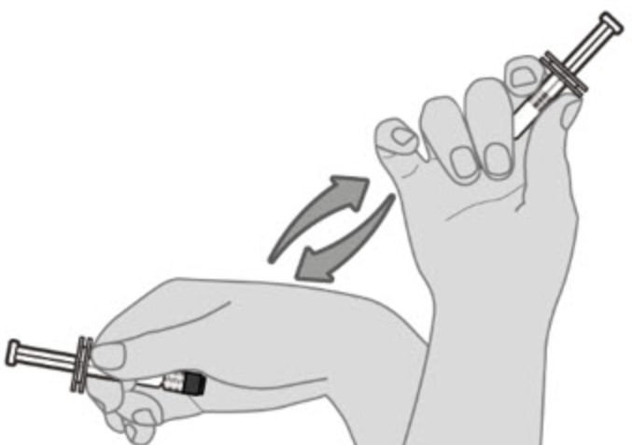  Step 1. Resuspend drug product  Hold the pre-filled syringe horizontally between the thumb and the forefinger and shake vigorously  until the vaccine is a homogeneous white suspension. Do not use the vaccine if it cannot be re-suspended.  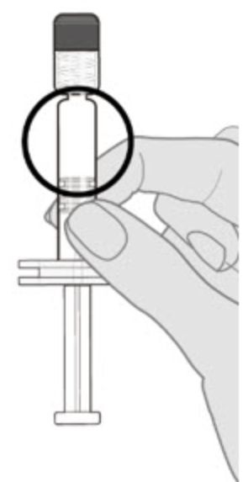  Step 2. Visual inspection  Visually inspect the vaccine for large particulate matter and discoloration prior to administration.  Do not use if large particulate matter or discoloration is found. If the vaccine is not a homogeneous  suspension, repeat Steps 1 and 2.  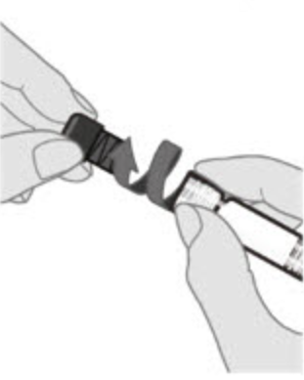  Step 3. Remove syringe cap  Remove the syringe cap by slowly turning the cap counterclockwise while holding the Luer lock adapter.  Avoid pressing the syringe plunger rod while removing the syringe cap.
Equipment/  Supplies | - Appropriate Pneumococcal Vaccine to be administered (i.e., PCV15, PCV20, or PPSV23)  - 23-25 gauge, 1-inch safety needle, or a 23-25 gauge, 5/8-inch needle if choosing to give the PPSV23 subcutaneously  - For larger individuals, 1.5-inch needle may be needed/more appropriate for intramuscular injections  - Alcohol swabs  - Nonsterile 2x2 woven gauze sponges  - Adhesive Bandages  - Exam gloves  - Hand sanitizer- waterless, containing at least 60% alcohol  - Sharps container  - Garbage receptacle
Vaccine Administration | - Cleanse hands with alcohol-based hand sanitizer or wash hands (if visibly soiled).  - Don gloves.  - Check vaccine expiration date and visibly inspect the vial for any irregularities, such as discoloration, particulate matter, damage, or contamination- If problems noted, the vial should not be used (check with administration for need to return to pharmacy for replacement).  - Prepare vaccination for administration (either attach needle to prefilled syringe or draw up appropriate dose needed for administration.  - Have individual sit in a chair or lie down for vaccination to prevent syncope.  - Choose the site for injection – deltoid muscle injection improves absorption of the vaccine. If this is not the first vaccination, choose the limb opposite the site of the previous injection.  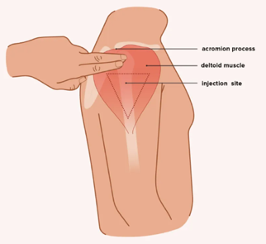  - Deltoid landmarks: 2-3 finger widths down from the acromion process; bottom edge is imaginary line drawn from axilla.  - Firmly spread skin with the thumb and index finger, grasping the muscle deeply on each side. Cleanse the injection site with alcohol swab and allow area to air dry.  - Insert the needle at a 90-degree angle.  - Release the isolated tissue when the needle is safely inserted.  - Inject the vaccine at a rapid rate, using a smooth continuous motion (this decreases the pain of injection).  - Withdraw the needle and engage built-in needle safety mechanism while simultaneously covering the injection site with clean gauze (hold gentle pressure).  - Immediately dispose of the needle/syringe set in the sharp’s container. Do not recap or remove the needle.  - Cover injection site with an adhesive bandage.  - Remove and dispose of gloves and other waste in garbage receptacle and cleanse hands with alcohol-based hand sanitizer. Clean vaccination area and prepare for vaccination of next individual if applicable.  - Monitor individual for 15 minutes (monitor for 30 minutes if individual has a history of non-severe allergic reaction to any previous vaccine or injectable therapy) post vaccination administration for any adverse reaction or side effect.  - Document procedure, noting date of vaccination, name of vaccine, lot number, expiration date, dose, site, route administered, publication date of VIS along with actual date given to individual.  - Residents – document in eMAR Preventative Health section (ensure to also document if vaccination was refused and reason for refusal, along with scanning the signed consent/declination into the chart).  - Employees – document on immunization screening and administration sheet. Make and retain a copy for employee’s health record with consent/declination, and give original to employee.
References:
- https://www.cdc.gov/vaccines/vpd/pneumo/hcp/recommendations.html
- https://www.cdc.gov/vaccines/vpd/pneumo/downloads/pneumo-vaccine-timing.pdf
- https://www.cdc.gov/vaccines/hcp/admin/downloads/job-aid-SCDM-PCV20-508.pdf
- https://www.cdc.gov/vaccines/vpd/pneumo/hcp/pneumoapp.html
- https://www.health.ny.gov/professionals/nursing_home_administrator/dal_nh_16-01_pneumococcal_vaccine.htm
- https://www.immunize.org/wp-content/uploads/catg.d/p3075.pdf
- https://www.cdc.gov/vaccines/acip/acip-scdm-faqs.html
- https://labeling.pfizer.com/ShowLabeling.aspx?id=15428
- https://www.merck.com/product/usa/pi_circulars/v/vaxneuvance/vaxneuvance_pi.pdf
- https://www.fda.gov/media/80547/download?attachment
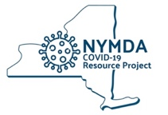 | Standing Orders Authorization
This non-patient specific order and policy and procedure shall remain in effect for all residents and employees of Insert Facility Name from the order beginning date of ____________ until ____________ or until rescinded, whichever occurs first.
_____________________________________ ___________________ __________________
Medical Director Signature License Number Date

